Request for Information (RFI)



“Analytics Engine Platform”

Issued by:
Advanced Technology International (ATI),
Countering Weapons of Mass Destruction Consortium
315 Sigma Drive
Summerville, SC 29486

Request Issue Date: March 31, 2026

Responses Due Date: April 24, 2026
12 Noon Eastern Time

DISCLAIMER
This is an information request only. This request is issued solely for information and planning purposes – it does not constitute a Request for Proposal (RFP) or a promise to issue an RFP in the future. Solicitations are not available currently. This notice does not constitute a commitment by the United States Government to contract for any supply or service whatsoever.

Purpose:
The Countering Weapons of Mass Destruction Consortium (CWMD) is pleased to issue this announcement for a Request for Information (RFI) on behalf of the Capability Program Executive Chemical, Biological, Radiological and Nuclear Defense (CPE CBRND) JPM CBRN Integrated Early Warning, acting through its Wearables Project Office, is developing a Wearables Family of Systems (FoS) to disrupt adversarial advancements in novel Chemical Biological (CB) threats by delivering wearable threat-agnostic sensing capabilities at speed and scale to enhance Joint Force readiness, response, and resiliency. To this end, JPM CBRN Integrated Early Warning is developing AI/ML models to monitor physiological status, predict CBRN-related effects, and support Warfighter tactical decision making, readiness, and recovery. JPM CBRN Integrated Early Warning also seeks to develop a unified, open data architecture and algorithm ecosystem to standardize data collection, storage, and streamline the development, deployment, and sustainment of AI/ML models. This is not a solicitation, and CPE CBRND is not requesting proposals at this time.

Requested Information of Interest:
In keeping with the strategic vision of Joint All-Domain Warfighting Operations (JADO), specifically the need to establish an enterprise-to-edge connected force, JPM CBRN Integrated Early Warning seeks to leverage rapid industry advancements in edge analytics to drive autonomous real-time decision making to edge devices. While significant constraints in computer processing, power and memory, still loom as impediments to performing analytics on edge devices at scale, JPM CBRN Integrated Early Warning is interested in identifying existing capabilities with potential to eventually deliver this capability.

The central interest of this information request is a universal model management software solution, henceforth referred to as an “Analytics Engine Platform (AEP)”, that standardizes the deployment of physiological monitoring and predictive models in cloud environments, localized servers and on edge devices. See Figure 1 for a graphic depicting the current state of model deployment and the desired end state of model deployment by way of the AEP. The prominent features of the AEP are identified within the shaded blue box.

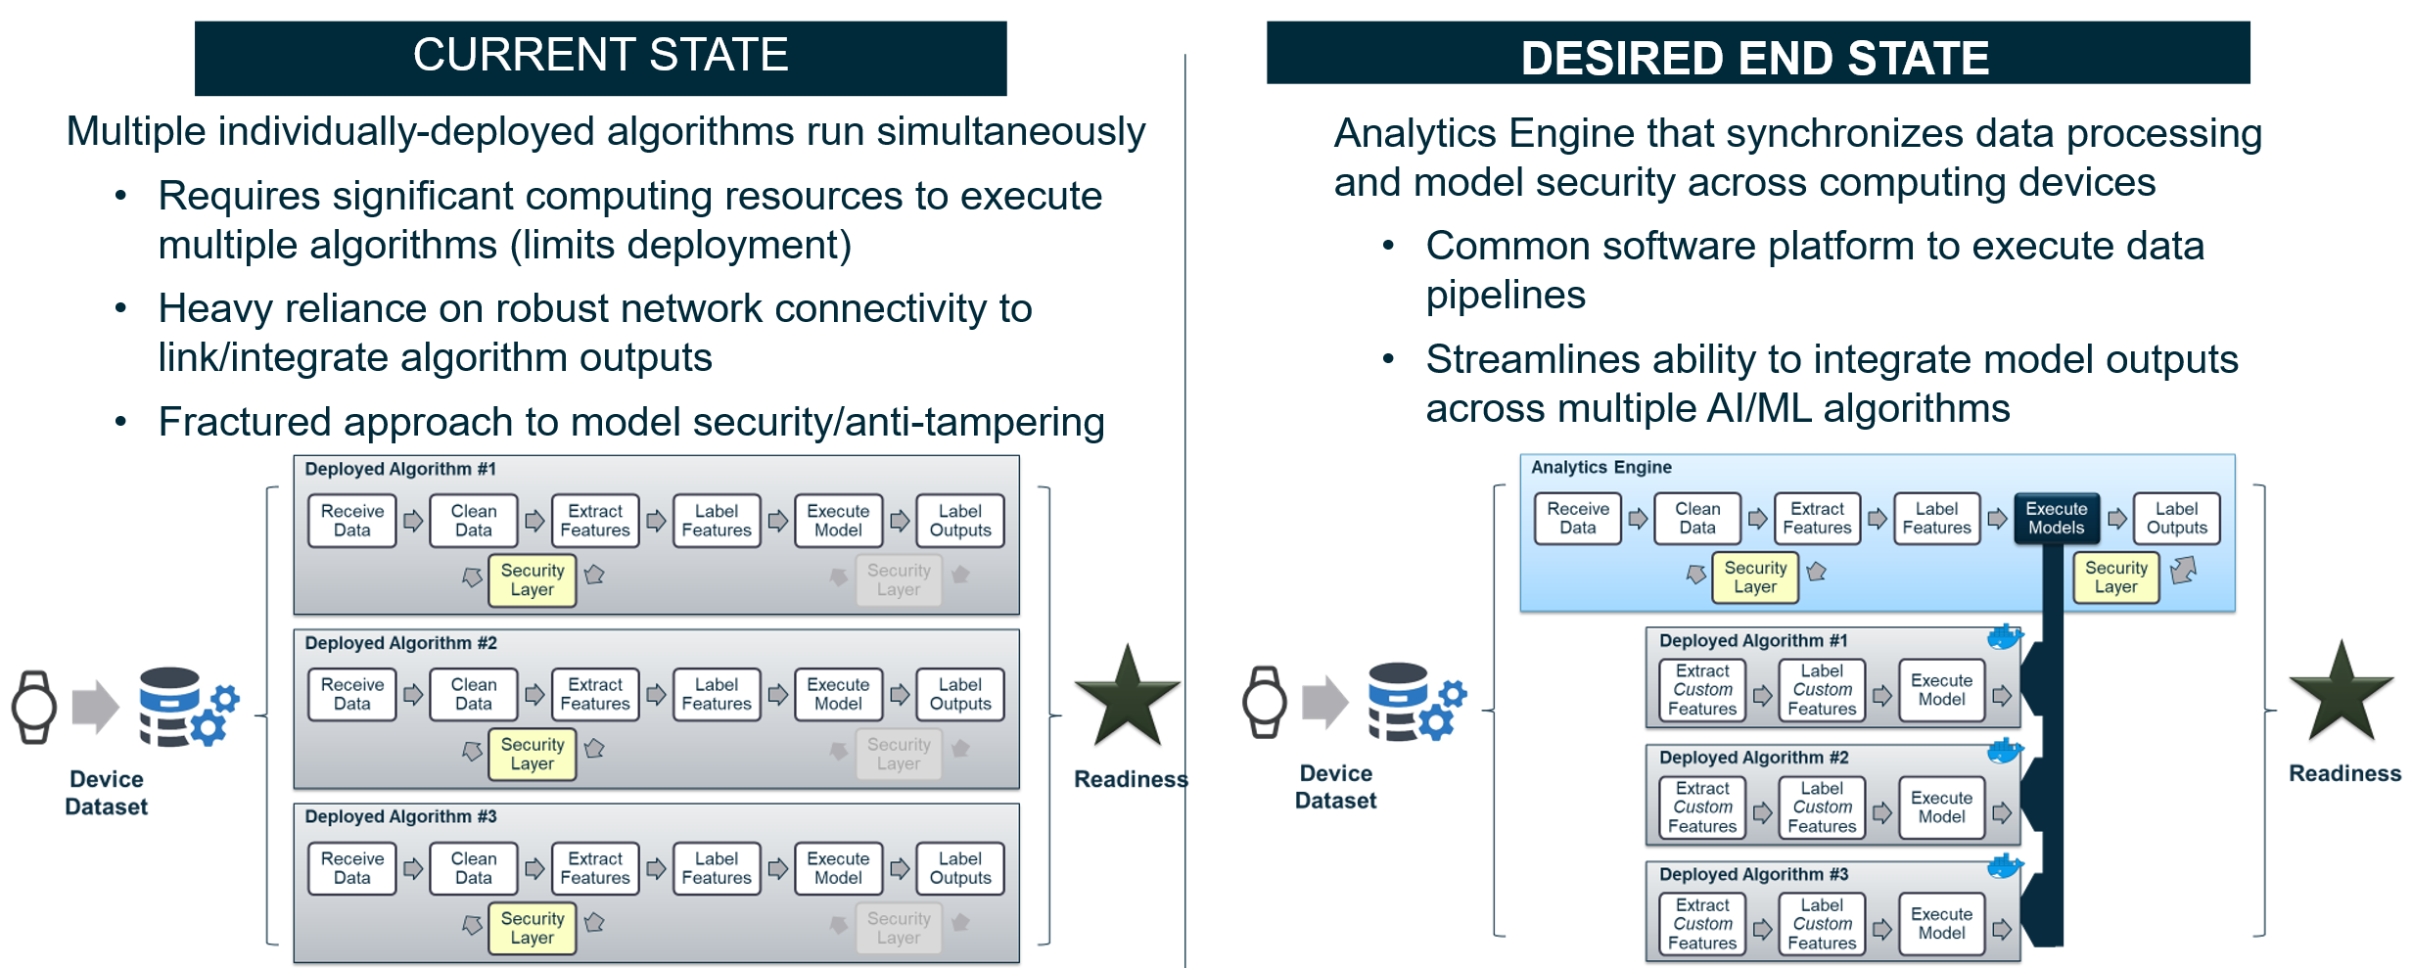

Figure 1. Current State Model Deployment vs. End State Model Deployment (Analytics Engine Platform)
The desired solution securely receives sensor data from various devices, standardizes the received data for model use, securely stores the standardized data, packages multiple models for continuous operation, deploys the trained models as a service, and securely transmits the model outputs to various devices. Additionally, the desired solution scales to address fluctuating traffic and optimize performance, supports multiple model deployment methods (i.e., batch, real-time, and streaming inferences), and extracts common features for use by the various models.

If your organization has the potential to provide an AEP solution(s) that meets the needs set forth in this information request, please respond via a short white paper that includes the following five sections:

- Introduction – A brief description of the timeline for developing your solution. Include a discussion of development partners and current ownership as well as the nature of the rights the Government reserves for usage modification of your solution.
- Capability Description – A brief capability statement describing your AEP solution. Please specify if your solution cannot currently satisfy the needs but is intended to at a future date. Elaborate on any dependencies on external partners.
- Technical Discussion – A description of how your AEP solution works. Please list the standard operating environments in which your AEP solution operates. Include a description of the computing environments in which your AEP solution operates (edge, server, cloud, and/or roadmap to incorporate all three components). Also describe what interference methods your AEP solution employs and which frameworks, libraries, and model formats your AEP solution supports. Similarly, provide details on your process for algorithm/model development (i.e., custom algorithms, third-party algorithms, etc.), including test, evaluation, and version control.
- Maturity and Implementation – Describe the maturity of your solution. Estimate the Technology Readiness Level (TRL). If the solution has been employed in a production environment, describe up to two use cases and respective implementations. Elaborate on performance of AEP solution in previous demonstrations (e.g., metrics of success, issues identified, resolutions, etc.). Provide rational for TRL to-date for all operational targets (i.e., local, cloud, edge). Additionally, identify any events planned/scheduled to increase the TRL levels (please specify the end TRL level after event(s)).
- Cost – Describe the Total Cost of Ownership (TOC) for your AEP solution. For this portion, assume user populations of 100 and 1,000 and provide responses for both. Describe how the TOC scales when ramping up from 100 to 1,000 users. Please specify any government rights, licensing, patents, proprietary usage, etc.

Collaborations or consortia involving teams with mature technologies should be submitted; however, such submissions must collectively deliver a complete, integrated, end-to-end solution that fully satisfies the functional, security, and scalability requirements described herein.

Administration:
The intent of this RFI is to understand CWMD member interest and technology capabilities within the above-mentioned focus area. Responses will be shared with the Government.

Responses may be submitted at any time during the submission period but no later than the due date and time specified on the first page of this RFI. Offerors are to submit:

- A white paper, not to exceed five content pages, that addresses the requested information discussed in above section, Requested Information of Interest. Whitepapers (using a minimum font size of 10 point) are to be submitted as .pdf files.
- A completed MS Excel-based questionnaire attached to this information request titled “AEP Questionnaire”. For all questions listed in column A of the “AEP Questionnaire” worksheet, please provide written responses in the adjacent cells in column B and cite any documentation that supports Column B responses in adjacent cells in Column C. Questionnaires are to be submitted as .xls files.

Responses must be sent to cwmd@ati.org with the subject line denoting the Responding organization and RFI Title. Material that is advertisement-only in nature is not desired.

CWMD membership is NOT required for the submission to this RFI. However, should this RFI result in a formal solicitation through the CWMD Consortium, membership will be required for submission of an Enhanced White Paper.

Note: This RFI is issued solely for information and planning purposes and does not constitute a solicitation. Neither unsolicited proposals nor any other kind of offers will be considered in response to this RFI. Responses to this notice are not offers and will not be accepted by the government to form a binding contract. Responders are solely responsible for all expenses associated with responding to this RFI. Request for Information papers should NOT include proprietary or classified information.

Points of Contact:
For inquiries, please direct your correspondence to the following contacts:
- Technical POC: Ronald Prescott, ronald.o.prescott.ctr@army.mil
- Contract POC: Charles Harris, charles.e.harris508.civ@army.mil
- Any general or administrative questions about the process for submitting responses to this information request may be directed to CWMD Program Manager, Mr. Robert Harwell, cwmd@ati.org

